<Project NAME>

To put in a client name select all (ctrl A) then f9Nash Tech Software Development

**Detailed Design**

**Version 1.0**

**7thMay, 2010**

13 Bruton Street

London

W1J 6QA

Tel: +44 (0)20 7333 0033

Fax: +44 (0)20 7333 0032

Email: [Tim.lewis@harveynash.com](mailto:Tim.lewis@harveynash.com)

DOCUMENT HISTORY

|  |  |  |  |  |
| --- | --- | --- | --- | --- |
| **Document Version History** | | | | |
| **Version** | **Date** | **Author** | **Reviewer** | **Details** |
| 0.1 | 07 May 2010 | Hung Nguyen |  | Create |
| 1.0 | 23 Jul 2010 | Hung Nguyen |  | Baseline |
| 1.0.1 | 11 Apr 2012 | Tham Tran | Ly Vo | Change company name |
|  |  |  |  |  |

**APPROVERS**

|  |  |  |  |
| --- | --- | --- | --- |
|  | Name & Role | Date | Signature |
| **Originator** |  |  |  |
| **Reviewer/s** |  |  | Trung Truong,Minh Bui, Nhan Nguyen |
|  |  |  |  |
| **Approver/s** |  |  | Cuong Nguyen |

**CONFIDENTIALITY**

This document is distributed on a restricted basis, is commercial in confidence to the recipient, and may not be used for any purpose other than that associated with a Nash Tech project. The contents of this document may not be disclosed to any third parties without the expressed advance written authorisation of Nash Tech.

TABLE OF CONTENTS

1 INTRODUCTION 3

1.1 Purpose 3

1.2 Scope 3

1.3 Definitions, Acronyms and Abbreviations 3

1.4 References 3

1.5 Overview 3

2 DESIGN SEPECIFICATION FOR <THE SPECIFIED USE CASE> 3

2.1 Summary 3

2.2 Use case diagram 4

2.3 Activity Diagram 4

2.4 Sequence Diagram 5

2.5 Screens Design 5

2.5.1. Screen XYZ 5

2.6 Class Diagram 6

2.7 Class Specification (s) 6

2.7.1. Classes Summary 6

2.7.2. Class Details 6

**2.7.2.1.** **Class XYZ** 6

**2.7.2.1.1.** **Attributes** 6

**2.7.2.1.2.** **Methods** 6

**2.7.2.1.3.** **[XXX] Method** 7

# INTRODUCTION

## Purpose

The purpose of the Detailed Design Document is to define the detailed design for all components of the website.

## Scope

This website allows user to post a topic for others to discuss about.

## Definitions, Acronyms and Abbreviations

|  |  |
| --- | --- |
| **Acronym** | **Reference** |
|  |  |
|  |  |
|  |  |

## References

[This subsection should provide a complete list of all documents referenced elsewhere in the Document. Each document should be identified by title, report number (if applicable), date, and publishing organisation. Specify the sources from which the references can be obtained. This information may be provided by reference to an appendix or to another document.]

## Overview

This DDD is organized as follow :

* Section 2.1 is summary of this use case
* Section 2.2 is class diagram of this use case
* Section 2.3 is use case diagram of this use case
* Section 2.4 is activity diagram of this use case
* Section 2.5 is sequence diagram of this use case
* Section 2.6 is class diagram of this use case
* Section 2.7 is classes summary of this use case

# DESIGN SEPECIFICATION FOR <POST TOPIC USE CASE>

## Summary

This use case describes how the user posts a topic to website.

## Use case diagram

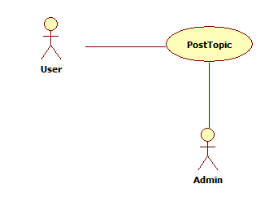

## Activity Diagram

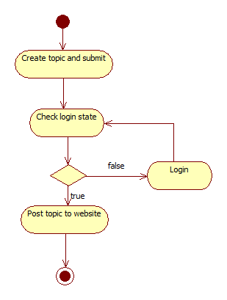

## Sequence Diagram

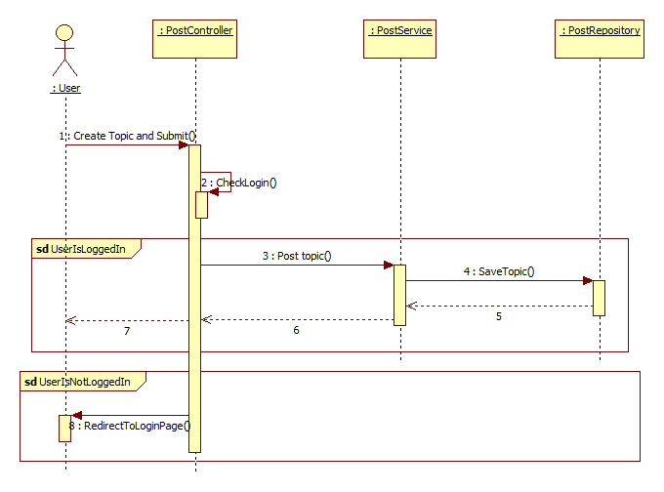

## Screens Design

### Screen XYZ

[Description the purpose of the screen as to ensure the client and developer agrees on its functionality.]

[include screen shot here]

**Security Group**: [List the security groups that may use the screen]

[Describe each field on the screen and how it is derived]

|  |  |  |
| --- | --- | --- |
| No | Data | Data Description |
| 01 | Data XYZ |  |
|  |  |  |

[Describe each action that can be performed from this screen. This usually involves command buttons, menu items, etc.]

|  |  |  |
| --- | --- | --- |
| No | Actions | Action Description |
| 01 | Action XYZ |  |
|  |  |  |

## Class Diagram

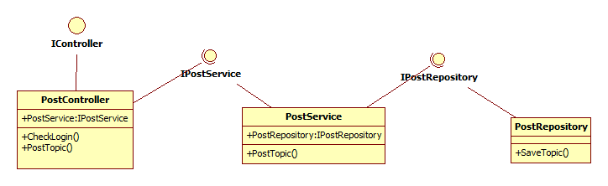

## Class Specification (s)

### Classes Summary

To be defined

### Class Details

To be defined

#### **Class PostController**

#### **Attributes**

|  |  |  |  |  |  |
| --- | --- | --- | --- | --- | --- |
| No | Attribute | Type | Default | Note | Description |
| 01 | PostService |  |  | Public | Implement IPostService which have method to save topic to database |
|  |  |  |  |  |  |
|  |  |  |  |  |  |

#### **Methods**

|  |  |  |
| --- | --- | --- |
| No | Method | Description |
| 01 | CheckLogin | Check if a user is logged in to website. If user is not logged in, he will be redirected to login page |
| 02 | PostTopic | Call PostService() to save topic |
|  |  |  |

#### **[XXX] Method**

|  |  |
| --- | --- |
| **Declaration** | |
| **Method Declaration** |  |
| **Description** |  |
| **Overrides** | |
| Not Applicable. | |
| **Parameter** | |
| **Name** | **Type** |
|  |  |
|  |  |
|  |  |
| **Return Type** | |
|  | |
| **Throws** | |
|  | |

##### Implementation

[How to implement the method, it can be in pseudo code or activity diagram or just words]

#### **Class PostService**

#### **Attributes**

|  |  |  |  |  |  |
| --- | --- | --- | --- | --- | --- |
| No | Attribute | Type | Default | Note | Description |
| 01 | PostRepository |  |  | Public | Implement IPostRepository which have method to save topic to database |
|  |  |  |  |  |  |
|  |  |  |  |  |  |

#### **Methods**

|  |  |  |
| --- | --- | --- |
| No | Method | Description |
| 02 | PostTopic | Call PostRepository() to save topic |
|  |  |  |
|  |  |  |

#### **Class PostRepository**

#### **Attributes**

|  |  |  |  |  |  |
| --- | --- | --- | --- | --- | --- |
| No | Attribute | Type | Default | Note | Description |
|  |  |  |  |  |  |
|  |  |  |  |  |  |
|  |  |  |  |  |  |

#### **Methods**

|  |  |  |
| --- | --- | --- |
| No | Method | Description |
| 02 | SaveTopic | Save topic to database |
|  |  |  |
|  |  |  |